Biology 12 - Respiration - Chapter Notes

• We often think of respiration as just breathing. In fact, breathing is just one part of this physiological process. As biologists, we divide respiration up into four areas:

Breathing | the movement of air into and out of the lungs
External Respiration | the exchange of O₂ and CO₂ between AIR and BLOOD.
Internal Respiration | the exchange of O₂ and CO₂ between BLOOD and TISSUE FLUID
Cellular Respiration | the process which produces ATP in mitochondria --> requires O₂ and releases CO₂

Breathing: bringing air to the lungs – get a diagram out
- inspiration:breathing air in
expiration: breathing air out
1. Air enters the nasal passages.
- hairs and cilia trap dust and debris
- the air is warmed and moistened.

2. The warmed and moistened air passes through the PHARYNX (a common passage for food and air).
- the nose contains two nasal cavities (narrow canals that are separated from one another by a SEPTUM). The nasal cavities are connected by tubes to the tear ducts (which is why you get a runny nose when you cry), and to the ears via the EUSTACHIAN TUBES.
- Special ciliated cells at the top recesses of the nasal cavities are scent receptors.
• When we breathe, the glottis (the opening to the LARYNX ("voice box")) is open, and when we swallow, the EPIGLOTTIS covers the glottis.

3. The air enters the larynx. It is like a triangular box with the Adam's Apple at the front corner.
- Elastic ligaments called vocal cords stretch from the back to the front of the larynx just at the sides of the glottis.
- These cords vibrate when air is expelled past them through the glottis. This vibrations produce sound.
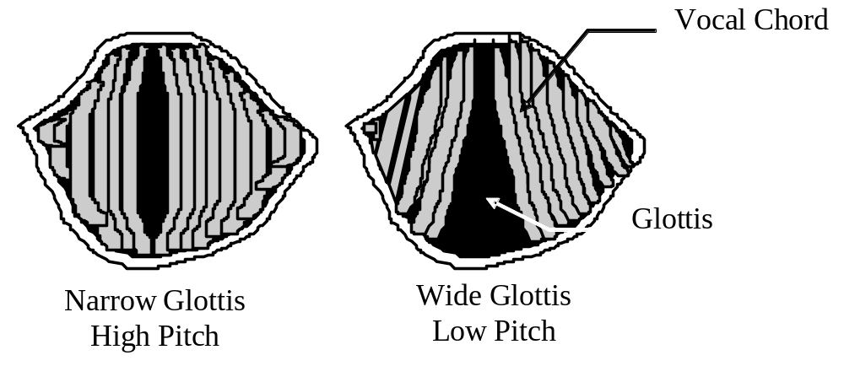
- The pitch of the voice depends on the length, thickness, and degree of elasticity of the vocal cords and the tension at which they are held.
- Muscles adjust the tension of the chords to produce different sounds.

4. The air enters the TRACHEA (windpipe). The trachea is held open by cartilaginous rings, and is lined with ciliated mucous membranes.
- The cilia beat upward to move up mucus and any dust or particles that were inhaled or accidentally swallowed. Smoking can destroy cilia.
- Tracheostomy:

an operation in which an incision is made into the trachea below a blockage (and a tube is then inserted).

5. The trachea divides into two bronchi, which branch into many smaller passages called bronchioles that extend into the lungs.
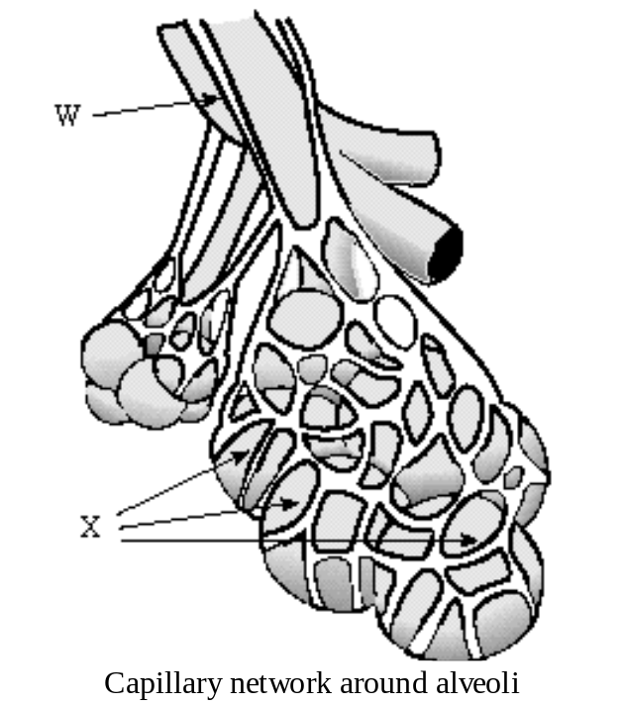

6. The bronchioles continue to branch out, and as they do, their walls get thinner and diameter smaller. Each bronchiole ends in sacs called alveoli, which fill up much of the lungs.
- There are approximately 300 million alveoli per lung, for a total of 150 m² of alveolar area (at least 40 time the area of the skin).
Each alveolar sac is enclosed by a single layer of simple squamous epithelial tissue, which is surrounded by capillaries carrying deoxygenated blood. GAS EXCHANGE occurs between blood and air in alveoli.

- The alveoli are lined with a film of lipoprotein to prevent them from collapsing when air leaves them.
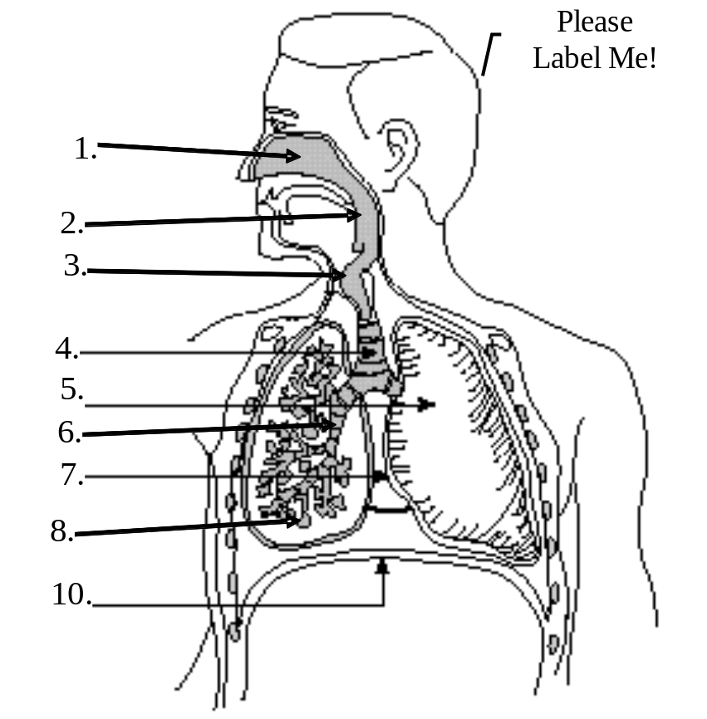
- The lungs themselves are cone-shaped organs that lie on both sides of the heart in the thoracic cavity. The branches of the pulmonary arteries follow the bronchial tubes and form a mass of capillaries around the alveoli. The right lung has 3 lobes and the left lung has 2 lobes. A lobe is divided into lobules, each of which has a bronchiole serving many alveoli.
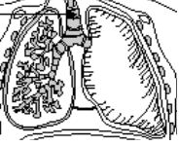
- Because so lungs contain so much air space, they are very light, and would float in water.

Name the parts of the respiratory system:

1.
2.
3.
4.
5.
6.
7.
8.
10.

- Breathing is powered by the diaphragm, a thick, dome-shaped muscle on the floor of the thoracic cavity (chest cavity).
- Lungs are enclosed by two pleural membranes. One pleural membrane lines the chest walls, and an inner membrane lines the lung. In between is fluid. This makes for an air-tight seal.
- What powers breathing? Creating “negative pressure” powers breathing. Negative pressure is air pressure that is less (756 mm Hg) than the pressure of the surrounding air (760 mm Hg). This negative pressure is created by increasing the volume inside the thoracic cavity. Air will naturally move in to fill this partial vacuum. The space in the thoracic cavity is made bigger by the contraction of the diaphragm muscle (this makes it move downward and become less dome shaped). When the diaphragm contracts, the space within lungs increases.

- The muscles attached to the ribs, called intercostal muscles, will also contract when you breathe in. This contraction pulls the ribs up and out, further increasing the space within the thoracic cavity.
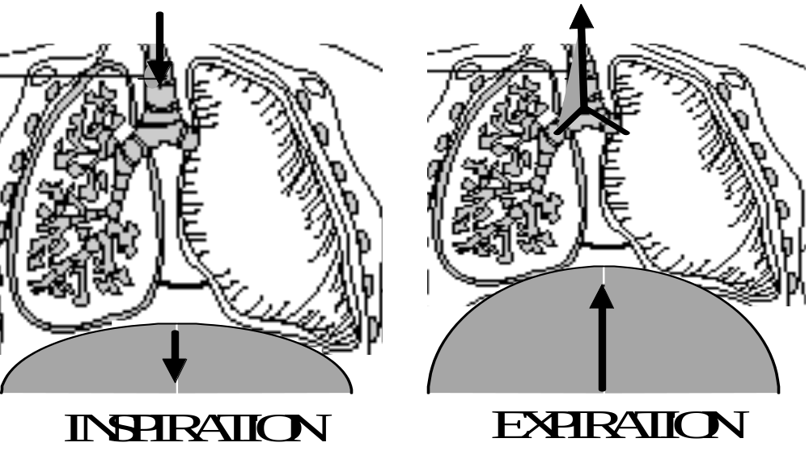

- The air pressure in the lungs becomes less than the atmospheric pressure. Air naturally rushes into the lungs to fill this natural vacuum.

- When the diaphragm relaxes, it moves up, and when the intercostal muscles relax, the ribs move down and inward. This decreases the volume in the thoracic cavity, and air is forced out of the lungs (expiration).

Quick Review
Using the information you just read, fill in the following data table:
Structure | Description | Function
Nasal Cavities

Pharynx

Glottis

Larynx

Trachea

Bronchi

Bronchioles

Alveoli

Control of Breathing

carbon dioxide and Hydrogen ions (H+) in the blood control the breathing rate.
1. CO₂ levels in the blood will increase as cells continue to produce it. The concentration of CO₂ will increase until they reach a threshold level.

2. Chemoreceptors in arteries detect the increased CO₂ and H⁺ levels.
3. The chemoreceptors send a signal to a breathing center in the MEDULLA OBLONGATA of the brain. It detects the rising levels of CO₂ and H⁺. This center is not affected by low oxygen levels. There are also chemoreceptors in the carotid bodies, located in the carotid arteries, and in the aortic bodies, located in the aorta, that respond primarily to H⁺ concentration, but also to the level of carbon dioxide and oxygen in the blood. These bodies communicate with the respiratory center.
4. The medulla oblongata sends a nerve impulse to the diaphragm and muscles in the rib cage.
5. The diaphragm contracts and lowers, while the rib cage moves up.
6. Air flows into alveoli, and the alveolar walls expand and stretch.
7. Stretch Receptors in the alveoli walls detect this stretching.
8. Nerves in alveoli send signal to brain to inhibit the medulla oblongata from sending its message to the diaphragm and rib muscles to contract. They therefore stop contracting.
9. The diaphragm relaxes, and moves upward, resuming its original shape. The rib cage relaxes and moves downward and inward.
10. Air is forced out the lungs.

- Thus, carbon dioxide levels in blood regulate breathing rate. Therefore, it is better to not give pure oxygen to a patient to get breathing going (should be a mixture of oxygen and carbon dioxide).
- The breathing rate is also subject to partial conscious control. Why do you suppose that is?

- Average human breathes in, on average, 500mL (or cc) of air per breath (this is called the tidal volume). The vital capacity is the maximum that can be breathed in per breath, and averages as much as 6000 mL or 6L!.)
- Only about 350 cc of the 500 cc normally breathed in actually gets down deep enough to reach the Alveoli. The other part of this air is stuck in bronchioles and doesn’t get to the alveoli. This area is called the "Dead Air Space". Breathing through a long tube increases the amount of dead space beyond maximum inspiratory capacity. Thereafter, death will occur because the air inhaled never reaches the alveoli. This is why you can’t breathe for very long through, for example, a garden hose.
- Also, some air (called "residual air") remains in lungs after expiration (about 1000mL).

Quick Review

1. What is the importance of a combination of intrinsic and extrinisic breathing control?

2. An experiment had participants count number of breaths per minute, then breathe into a paper bag. The following results were obtained.

Participant | Before bag Breathing Rate (breaths/min) | After Bag Breathing Rate (breaths/min)
.1 | 20 | 25
2 | 22 | 27
3 | 17 | 23

Explain the results.

External Respiration: exchange of gases in the lungs
External Respiration: gas exchange between air (at alveoli) and blood (in pulmonary capillaries).

- Both alveoli walls and capillary walls are one cell layer thick.
- This exchange of gases is by diffusion alone. (recall that the law of diffusion states that material will flow from area of high concentration to area of low concentration).

 | [O₂] | [CO₂]
capillaries | low | high
alveoli | high | low

- Deoxygenated blood is high in CO₂, which is carried as bicarbonate ion (HCO₃-).
 | carbonic anhydrase in RBC
H+ + HCO₃- | ----------------> | H₂O + CO₂
in blood | <---- | to alveoli
- The above reaction is driven to the right as CO₂ leaves the blood, and is sped up by the enzyme carbonic anhydrase in red blood cells.

Hemoglobin - review
- Hemoglobin is an iron-containing respiratory pigment found within red blood cells.
- There are about 200 million hemoglobin molecules per RBC.
- Hemoglobin increases the oxygen carrying capacity of blood by 60X or more
- Hemoglobin is composed of 4 polypeptide chains connected to 4 heme groups (contain iron).
- The iron portion forms a loose association with O₂. Four O₂ bind per hemoglobin molecule.
- How does hemoglobin work?

It is more attracted to oxygen in cool, more basic lungs, and less attracted to oxygen in the more acidic, warmer tissues.

- Hb will bind O₂ in the lungs, and release it in tissues.
 | LUNGS
Hb + O₂ | -----------> | HbO₂
reduced Hemoglobin | <----------- | oxyhemoglobin
dark purple | TISSUES | bright red
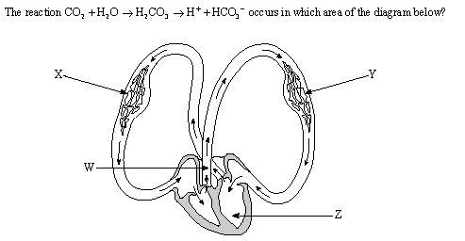

- Hemoglobin takes up O₂ in increasing amounts as Pressure of O₂ increases until about 100 mm Hg.

Using the tables below, determine the effect of temperature and pH on Hemoglobin and oxygen uptake.
Temperature Effects:

Hb takes up O₂ more readily in low temperatures (lungs), gives up O₂ more readily at higher temperature.

pH Effects:
Hb takes up O₂ more readily in the more basic or neutral lungs, and gives it up more readily in the more acidic tissues.

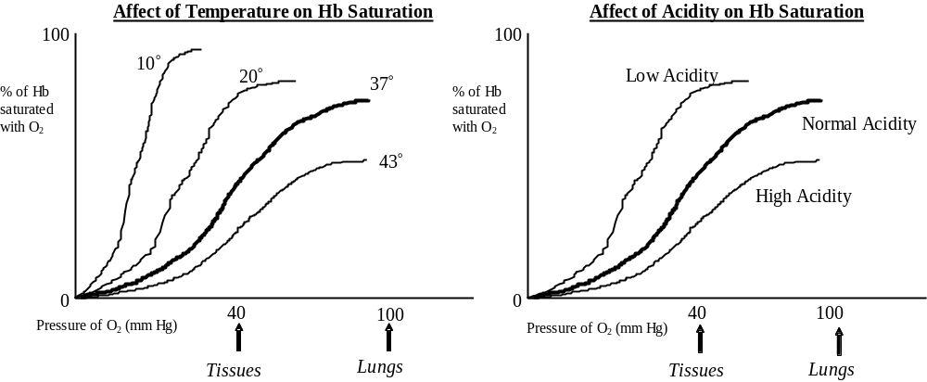

Internal Respiration: Exchange of Gases in the Tissues

Internal respiration: the exchange of O₂ and CO₂ between BLOOD and TISSUE FLUID.

- Oxygen diffuses from the systemic capillaries (blood) into tissue fluid. HbO₂ -----> Hb + O₂
- Tissue fluid is low in O₂, high in CO₂, due to constant cellular respiration. CO₂ therefore diffuses into the blood.

The Fate of CO₂

- A small amount of CO₂ is taken up by hemoglobin.
 | TISSUES
Hb + CO₂ | -----------> | HbCO₂
 | <----------- | carbaminohemoglobin
 | LUNGS

- Most CO₂ combines with H₂O to form carbonic acid, which then dissociates to H+ and HCO₃-.
CO₂ + H₂O | ----> | H₂CO₃ | ----> | H+ + | HCO₃-
 |  |  |  | to Hb | to Plasma

⇒ Note: Hemoglobin combines with the excess H+ that this reaction produces. That way, blood pH remains constant. You could say that Hemoglobin acts like a buffer.

Respiratory Disorders

1. Common Cold: Caused by viral infection. About 150 viruses known to cause colds.
- Mild symptoms: sore throat, watery mucusy nasal discharge.
- No Cure -- treat symptoms. Antihistamines, decongestants, ASA, rest.

2. Influenza: a more severe viral infection.

- Symptoms include fevers, aches, cold symptoms. Vaccines have been developed, but the virus is constantly mutating into new forms. Over 20,000,000 people died in a flu epidemic in 1919-20.

3. Bronchitis: usually caused by: viral infection of nasal cavities that spreads to bronchi and causes a secondary bacterial infection.

In acute bronchitis, there is heavy mucoid discharge, coughing.
Chronic bronchitis is not usually due to bacterial infection, but rather to: chronic irritation of bronchial lining (leads to degeneration of lining, loss of cilia.)
Chronic bronchitis is usually due to smoking.
- Treatment for acute bronchitis is antibiotics and rest.

4. Pneumonia: caused by: bacteria or viruses which infect lungs.
The lobes of the lungs fill up with mucus and pus.
- Many AIDS patients die of Pneumocystis carinii infection.
- Treatment is antibiotics (if bacterial), hospitalization.
5. Emphysema: most often caused by: smoking
- Deteriorating bronchioles ----> alveoli cut off. This leads to ballooning of lungs due to trapped air. The trapped air causes the alveoli to rupture.
- Symptoms include coughing, sluggishness, heart racing. The heart and brain starve for oxygen. May lead to a heart condition.
- Hard to treat: often surgical removal of some lung tissue helps.

6. Tuberculosis: caused by: tubercle bacteria. Can detect with a skin test, X-Rays.
- If the bacilli invade lungs, cells the invaders with capsule called tubercles (a defense mechanism). This may kill sufferer.
- Treatment: quarantine, antibiotics, other drugs.

7. Lung Cancer: Smoking is the #1 cause!.
- Lung cancer is a progressive disease --> early detection is important.
Progress of disease:
- Lungs exposed to carcinogenic irritants.
- Bronchial cells thicken, callus, cilia die.
- "Atypical" cells start appearing in thickened lining ("in situ" cancer).
- Some of these cells break loose and penetrate other tissues (= metastasis). This is the point where true cancer begins.
- Tumor(s) grow, tubes become blocked, lung collapses, secondary infections can occur.

Treatment: chemotherapy, surgery, pneumonectomy (remove lung).

Smoking Risks (a partial list):
- lung cancer | - bronchitis/emphysema
- larynx cancer | - peptic ulcers
- bladder cancer | - reduced lifespan
- pancreas cancer | - weak immune system

Quick Review:

Disorder | Cause | Pathogenicity
Emphysema
Smoking
(#1 cause)

 |  | Lungs fill with mucus and pus
Chronic Bronchitis

Some examples of what these conditions look like:

Healthy lung tissue

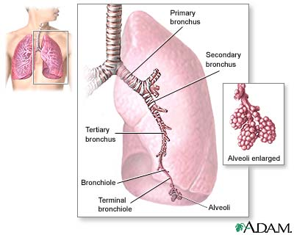

Tuberculosis

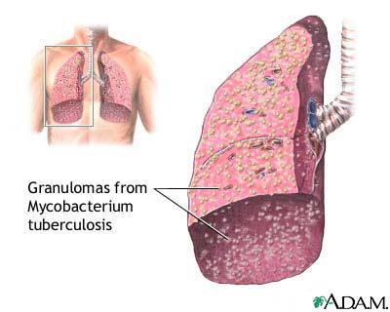

Opened chest, exposing lung tissue infected with tuberculosis
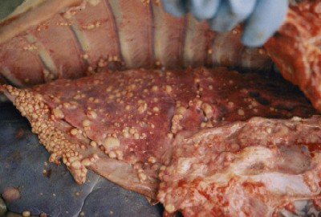

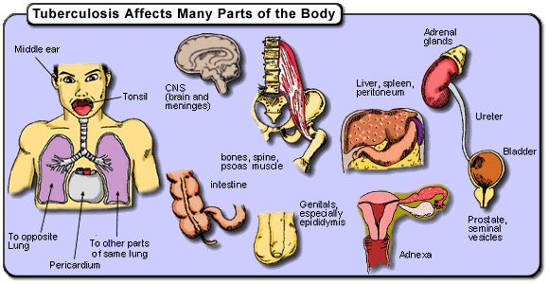

Tuberculosis in the kidney

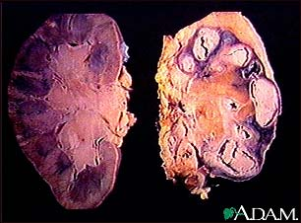

Kidneys can be damaged by tuberculosis. Tuberculosis generally affects the lungs, but may cause infection in many other organs in the body.

Comparison of healthy lung tissue with that of an emphysema sufferer.

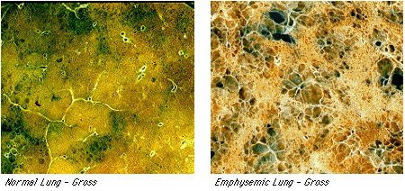

It’s much more difficult to inflate the lungs affected by emphysema.

Chronic obstructive pulmonary disease (COPD) refers to chronic lung disorders that result in blocked air flow in the lungs. The two main COPD disorders are emphysema and chronic bronchitis, the most common causes of respiratory failure. Emphysema occurs when the walls between the lung's air sacs become weakened and collapse. Damage from COPD is usually permanent and irreversible.

Chronic Obstructive Pulmonary Disease
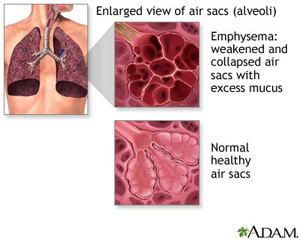

Non-small cell carcinoma

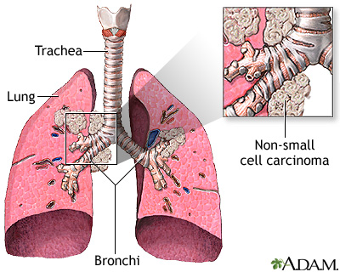
Non-small cell carcinomas are the most common lung cancers.

Lung cancer, frontal chest x-ray

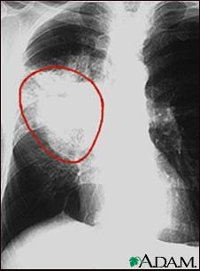
A patient with central cancer of the right lung. Notice the white mass in the middle portion of the right lung (seen on the left side of the picture)

.

